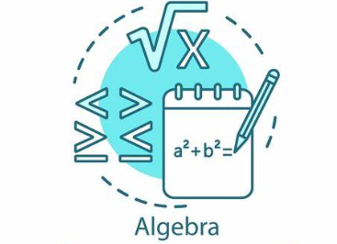**WEEK AT A GLANCE**

**August 6th to August 9th**

**Tuesday:** Using Simulations to Model Chance Behavior Learning Task Location: Unspecified Learning Target: I am learning how to use a simulation to model chance behavior. Success Criteria: I can determine the probability of an event through simulation and theoretical methods. 1) Syllabus 2) Class Norms 3) Using Simulations to Model Chance Behavior Learning Task Using-Simulation-to-Model-Chance-Behavior-Student-Reproducibles-Advanced-Algebra-Unit-1 (gadoe.org)

**WEDNESDAY:** Are Soda Contests True? Learning Task Location: Unspecified Learning Target: I am learning how to find the true probability of an event by replicating the event many, many times. Success Criteria: I can use a frequency table with tally marks to record-real world data in a simulation. Using-Simulation-to-Model-Chance-Behavior-Student-Reproducibles-Advanced-Algebra-Unit-1 (gadoe.org)

**THURSDAY:** Formative Assessment Simulations, Probability, Evidence, and Frequency Location: Unspecified Learning Target: I am learning how to determine if there is “convincing evidence” to support a claim. Success Criteria: I can determine and calculate the probability of an event from a dot plot. Formative Assessment Topics: Simulation Probability Evidence Frequency

**FRIDAY:** Descriptive and Inferential Vocabulary Day Location: Unspecified Learning Target: I am learning about vocabulary used with descriptive and inferential statistics. Success Criteria: I can categorize sources of data collection and use vocabulary, in context.

1. Normalizing Multiple Attempts in Mathematics Diagnostic

2. Descriptive and Inferential Statistics Vocabulary Activity

***Vocabulary Quiz Monday August 12th***

***Vocabulary for Unit 1: Descriptive and Influential Statistics***

1. simulation: a way to model random events, such that simulated outcomes closely match real-world outcomes

2. trial: a single performance of a well-defined experiment

3. experiment: a treatment is deliberately imposed on individuals in order to observe their responses

4. treatment: a specific experimental condition applied to the subjects of an experiment

5. observational study : individuals are observed and variables of interest are measured without any attempt to influence responses

6. sample space: the set of all possible outcomes of a statistical experiment

7. probability: A number between 0 and 1 used to quantify how likely something is to happen

8. percentile: a number between 0 and 100 that indicates the percent of a distribution that is equal to or below it

9. population: the entire pool from which a statistical sample is drawn

10. parameter: a numerical characteristic of a population

11. sample: a small part or quantity intended to show what the whole is like

12. statistic: a numerical characteristic of a sample

13. Law of Large Numbers: the more repetitions that occur, the proportion of times that a specific event will occur approaches a single value

14. primary data: data that is collected by a researcher from first-hand sources

15. secondary data: data gathered from studies, surveys, or experiments that have been run by other people